VENDING MACHINE MECHANISM

**CAPTION**

Similar to the development of traditional [mobile phones](https://en.wikipedia.org/wiki/Mobile_phone) into [smartphones](https://en.wikipedia.org/wiki/Smartphone), vending machines have also progressively evolved into smart vending machines. Newer technologies at a lower cost of adoption, such as the large digital [touch display](https://en.wikipedia.org/wiki/Touchscreen), internet connectivity, cameras and various types of sensors, more cost-effective [embedded computing](https://en.wikipedia.org/wiki/Embedded_computing) power, [digital signage](https://en.wikipedia.org/wiki/Digital_signage), various advanced payment systems, and a wide range of identification technology ([NFC](https://en.wikipedia.org/wiki/Near_field_communication), [RFID](https://en.wikipedia.org/wiki/Radio-frequency_identification), etc.)have contributed to this development.

**CONTENT**

A vending device for vending machines comprises a spiral coil connected to a coin-operated mechanism that allows rotation thereof and the connected coil when foreordained coins have been inserted into the mechanism.

The loops making up the coil comprise closely spaced adjacent loops, remote from the mechanism, capable of supporting and transporting product to be vended as the coil is rotated, and greatly spaced neighboring loops, not able of supporting the product.



As the coil is turned, product is transported toward the mechanism until it reaches the distantly spaced loops where it drops from the spiral into a chute accessible by the buyer. The mechanism is rotated by coin receivers that are blocked from rotating by spring-urged pawls unless foreordained coins have been inserted therein, or unless disabling tabs are interposed between the receivers and the pawls. Mediation of fitting tabs permits price changes to be affected by preventing the pawls from stopping the rotation of coin receivers thus disabled.



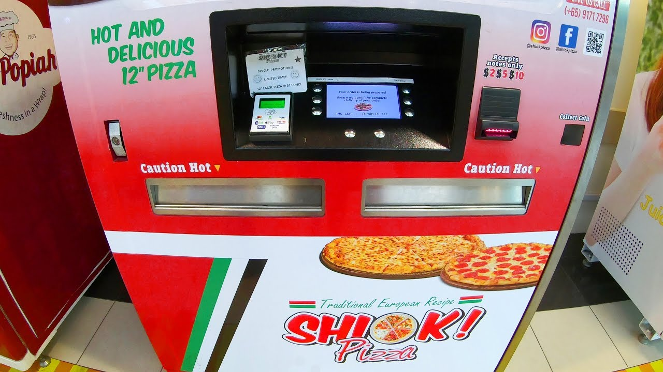

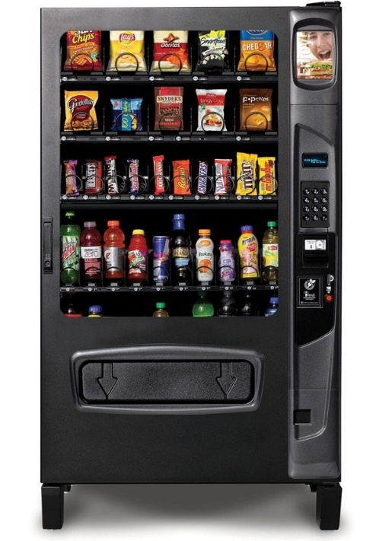 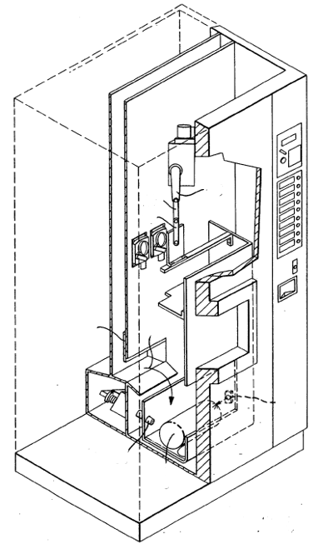



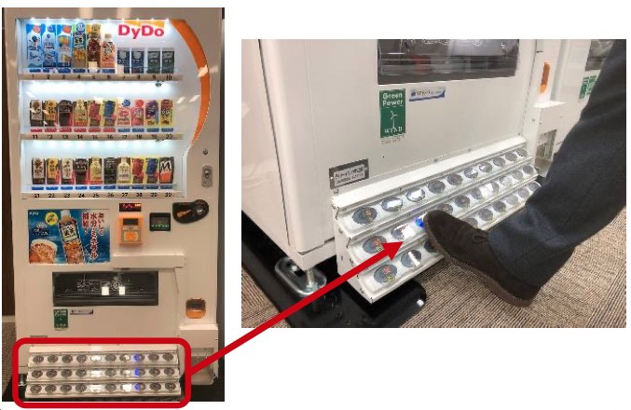



**FOOT OPERATED VENDING MACHINE**

